

PFA HOUSING PROJECT

Submitted by:

Akshat Sharma

**ACKNOWLEDGMENT**

The research, references and data source I got for this PFA housing project is from Flip robo technologies which guided me to get complete analysis through this project.

**INTRODUCTION**

* Business Problem Framing

Houses are one of the necessary need of each and every person around the globe and therefore housing and real estate market is one of the markets which is one of the major contributors in the world’s economy. It is a very large market and there are various companies working in the domain. Data science comes as a very important tool to solve problems in the domain to help the companies increase their overall revenue, profits, improving their marketing strategies and focusing on changing trends in house sales and purchases. Predictive modelling, Market mix modelling, recommendation systems are some of the machine learning techniques used for achieving the business goals for housing companies. Our problem is related to one such housing company

* Conceptual Background of the Domain Problem

A US-based housing company named Surprise Housing has decided to enter the Australian market. The company uses data analytics to purchase houses at a price below their actual values and flip them at a higher price. For the same purpose, the company has collected a data set from the sale of houses in Australia. The data is provided in the CSV file below. The company is looking at prospective properties to buy houses to enter the market. You are required to build a model using Machine Learning in order to predict the actual value of the prospective properties and decide whether to invest in them or not. For this company wants to know:

* Which variables are important to predict the price of variable?
* How do these variables describe the price of the house?
* Review of Literature

The comprehensive summary of the research done on the project is the higher the number of utilities in the house , will be having high sale price of houses.

I was required to model the price of houses with the available independent variables. This model will then be used by the management to understand how exactly the prices vary with the variables. They can accordingly manipulate the strategy of the firm and concentrate on areas that will yield high returns. Further, the model will be a good way for the management to understand the pricing dynamics of a new market and my model score is 89.9.

* Motivation for the Problem Undertaken

My objective behind to make this project is to find out the reason and utilities that are considered within to declare a house sale price at a particular places which involves number of factors ad where these all factors are co related to declare the house sale prices.

**Analytical Problem Framing**

* Mathematical/ Analytical Modeling of the Problem

Descriptive and prescriptive modelling is performed during the model construction with having data set of 1000 records with 80 columns. Prediction made is by filling null values with mode.

* Data Sources and their formats

Data contains 1460 entries each having 81 variables.

Data contains Null values.

DATA SOURCE is from flip robo technologies where I was required to model the price of houses with the available independent variables. This model will then be used by the management to understand how exactly the prices vary with the variables.

* Data Pre-processing Done

Only assumptions made is that, outliers weren’t removed as I was losing too much data and also null values filled with mode mostly.

Cleaning of data done via filling/dropping null values as

LotFrontage 18.3219 % Missing Values

Alley 93.4075 % Missing Values

MasVnrType 0.5993 % Missing Values

MasVnrArea 0.5993 % Missing Values

BsmtQual 2.5685 % Missing Values

BsmtCond 2.5685 % Missing Values

BsmtExposure 2.6541 % Missing Values

BsmtFinType1 2.5685 % Missing Values

BsmtFinType2 2.6541 % Missing Values

FireplaceQu 47.1747 % Missing Values

GarageType 5.4795 % Missing Values

GarageYrBlt 5.4795 % Missing Values

GarageFinish 5.4795 % Missing Values

GarageQual 5.4795 % Missing Values

GarageCond 5.4795 % Missing Values

PoolQC 99.4007 % Missing Values

Fence 79.7089 % Missing Values

MiscFeature 96.2329 % Missing Values

Mostly features having more than 75% data missing were removed

* Data Inputs- Logic- Output Relationships

**The train dataset has 1168 rows and 81 columns. 2. The test dataset has 292 rows and 80 columns**

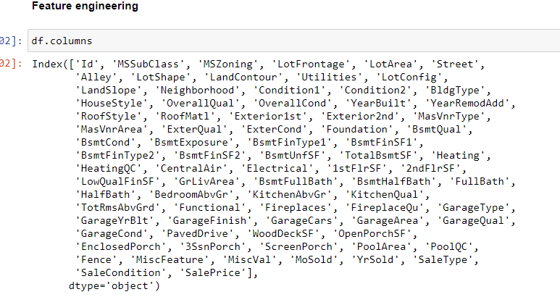

**Starting from society to the end of bathroom/basement, house project has every kind of column when it comes to sale prices and sale of house and these input features affected output target in a way where every utility is defined to increase/decrease house prices in a way.**

* State the set of assumptions (if any) related to the problem under consideration
* Descriptive and prescriptive modelling is performed during the model construction with having data set of 1000 records with 80 columns. Prediction made is by filling null values with mode and outliers weren’t removed as it got handled by regressor booster.
* Hardware and Software Requirements and Tools Used

Listing down the hardware and software requirements along with the tools, libraries and packages used-

**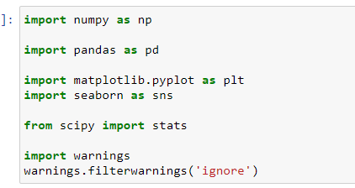**

**These packages were used for making lot of graph to check the effect on sale prices and for data cleaning and feature engineering**

Other than that standard scaler was used to scale the data and for model building -

**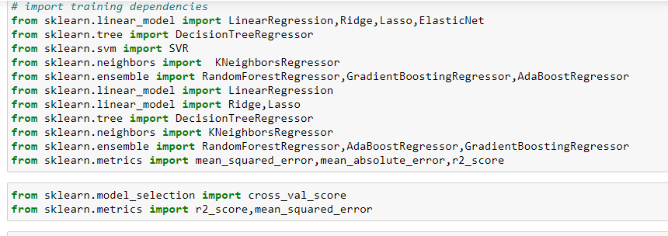**

model building algorithms were used and cross validation score was checked so imported above from scikitlearn libraries.

**Model/s Development and Evaluation**

* Identification of possible problem-solving approaches (methods)

After data cleaning, as data was getting loss from removing the outliers so outliers weren’t removed as it was taken care by boosting techniques used under model building and standard scaler was used for scaling process and for visualisation , every column was checked for the effect of input to output via violin, rel plot, bar graphs etc.

Testing of Identified Approaches (Algorithms)



R2 score was checked for the best model algorithm and also cross validation score was checked and finally randomised search cross validation was used to get 89.9 score for the model

* Run and Evaluate selected models

**Linear Regression**

Linear regression is been studied at great length, and there is a lot of literature on how your data must be structured to make best use of the model.

As such, there is a lot of sophistication when talking about these requirements and expectations which can be intimidating. In practice, you can uses these rules more as rules of thumb when using Ordinary Least Squares Regression, the most common implementation of linear regression.

Try different preparations of your data using these heuristics and see what works best for your problem.

* **Linear Assumption.** Linear regression assumes that the relationship between your input and output is linear. It does not support anything else. This may be obvious, but it is good to remember when you have a lot of attributes. You may need to transform data to make the relationship linear (e.g. log transform for an exponential relationship).
* **Remove Noise.** Linear regression assumes that your input and output variables are not noisy. Consider using data cleaning operations that let you better expose and clarify the signal in your data. This is most important for the output variable and you want to remove outliers in the output variable (y) if possible.
* **Remove Collinearity.** Linear regression will over-fit your data when you have highly correlated input variables. Consider calculating pairwise correlations for your input data and removing the most correlated.
* **Gaussian Distributions.** Linear regression will make more reliable predictions if your input and output variables have a Gaussian distribution. You may get some benefit using transforms (e.g. log or BoxCox) on you variables to make their distribution more Gaussian looking.
* **Rescale Inputs:** Linear regression will often make more reliable predictions if you rescale input variables using standardization or normalization.

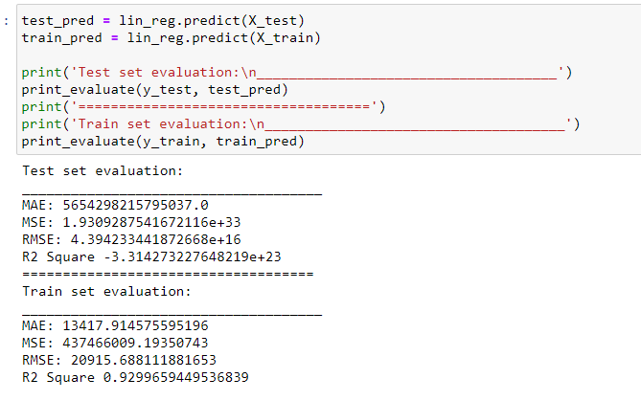

## Random Sample Consensus - RANSAC

Random sample consensus (RANSAC) is an iterative method to estimate parameters of a mathematical model from a set of observed data that contains outliers, when outliers are to be accorded no influence on the values of the estimates. Therefore, it also can be interpreted as an outlier detection method.

A basic assumption is that the data consists of "inliers", i.e., data whose distribution can be explained by some set of model parameters, though may be subject to noise, and "outliers" which are data that do not fit the model. The outliers can come, for example, from extreme values of the noise or from erroneous measurements or incorrect hypotheses about the interpretation of data. RANSAC also assumes that, given a (usually small) set of inliers, there exists a procedure which can estimate the parameters of a model that optimally explains or fits this data.

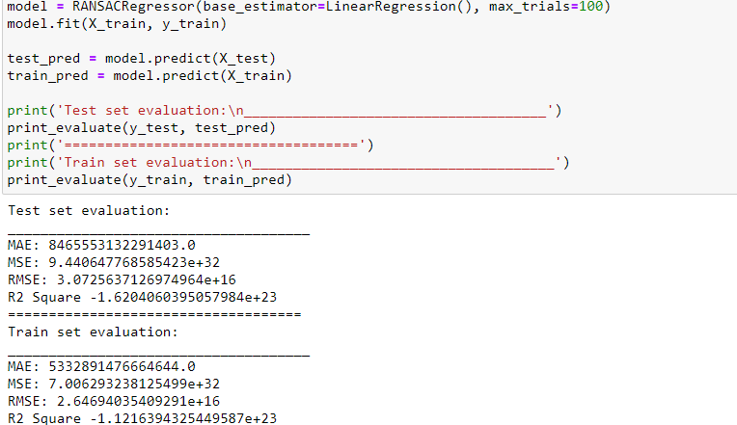

# 3. Ridge Regression

Source: [scikit-learn](http://scikit-learn.org/stable/modules/linear_model.html" \l "ridge-regression" \t "_blank)

Ridge regression addresses some of the problems of **Ordinary Least Squares** by imposing a penalty on the size of coefficients. The ridge coefficients minimize a penalized residual sum of squares,

min𝑤||||𝑋𝑤−𝑦||||22+𝛼||||𝑤||||22minw||Xw−y||22+α||w||22

𝛼>=0α>=0 is a complexity parameter that controls the amount of shrinkage: the larger the value of 𝛼α, the greater the amount of shrinkage and thus the coefficients become more robust to collinearity.

Ridge regression is an L2 penalized model. Add the squared sum of the weights to the least-squares cost function.

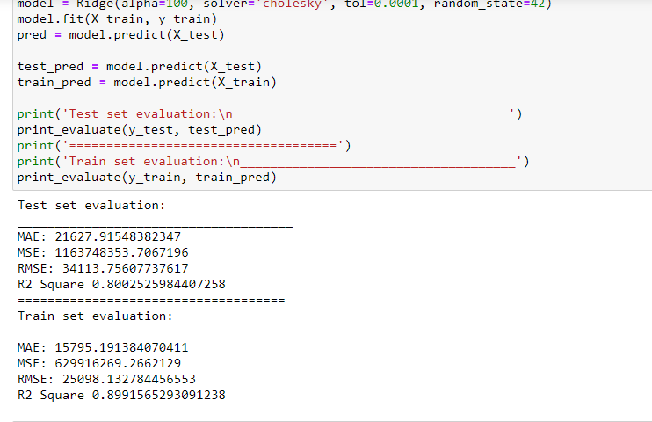

# 4. LASSO Regression

A linear model that estimates sparse coefficients.

Mathematically, it consists of a linear model trained with ℓ1ℓ1 prior as regularizer. The objective function to minimize is:

min𝑤12𝑛𝑠𝑎𝑚𝑝𝑙𝑒𝑠||||𝑋𝑤−𝑦||||22+𝛼||||𝑤||||1minw12nsamples||Xw−y||22+α||w||1

The lasso estimate thus solves the minimization of the least-squares penalty with 𝛼||||𝑤||||1α||w||1 added, where 𝛼α is a constant and ||||𝑤||||1||w||1 is the ℓ1−𝑛𝑜𝑟𝑚ℓ1−norm of the parameter vector.

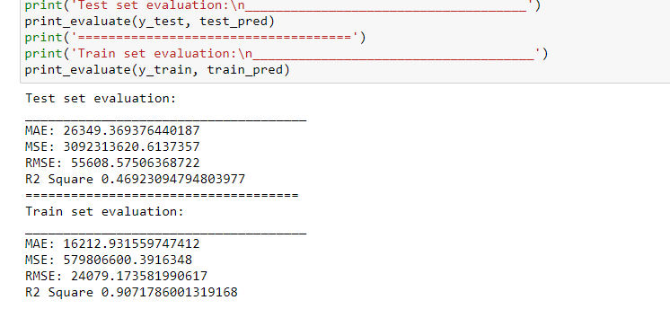

# 5. Elastic Net

A linear regression model trained with L1 and L2 prior as regularizer.

This combination allows for learning a sparse model where few of the weights are non-zero like Lasso, while still maintaining the regularization properties of Ridge.

Elastic-net is useful when there are multiple features which are correlated with one another. Lasso is likely to pick one of these at random, while elastic-net is likely to pick both.

A practical advantage of trading-off between Lasso and Ridge is it allows Elastic-Net to inherit some of Ridge’s stability under rotation.

The objective function to minimize is in this case

min𝑤12𝑛𝑠𝑎𝑚𝑝𝑙𝑒𝑠||||𝑋𝑤−𝑦||||22+𝛼𝜌||||𝑤||||1+(1−𝜌)2||||𝑤||||22

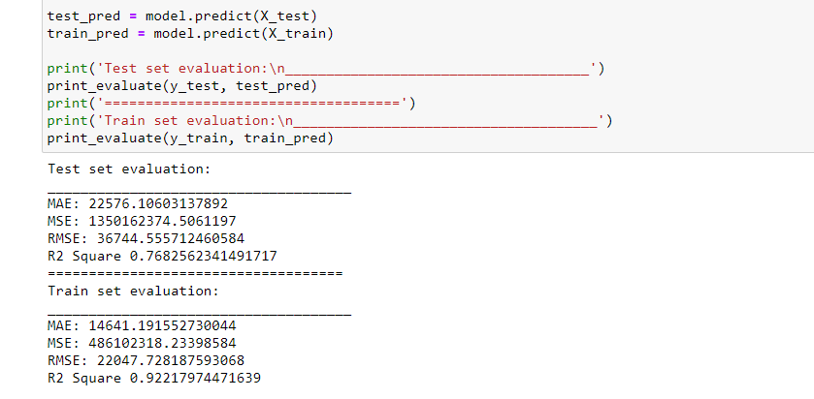

# 6. Polynomial Regression

Source: [scikit-learn](http://scikit-learn.org/stable/modules/linear_model.html" \l "polynomial-regression-extending-linear-models-with-basis-functions" \t "_blank)

One common pattern within machine learning is to use linear models trained on nonlinear functions of the data. This approach maintains the generally fast performance of linear methods, while allowing them to fit a much wider range of data.

For example, a simple linear regression can be extended by constructing polynomial features from the coefficients. In the standard linear regression case, you might have a model that looks like this for two-dimensional data:

𝑦̂ (𝑤,)=𝑤0+𝑤1𝑥1+𝑤2𝑥2y^(w,x)=w0+w1x1+w2x2

If we want to fit a paraboloid to the data instead of a plane, we can combine the features in second-order polynomials, so that the model looks like this:

𝑦̂ (𝑤,)=𝑤0+𝑤1𝑥1+𝑤2𝑥2+𝑤3𝑥1𝑥2+𝑤4𝑥21+𝑤5𝑥22y^(w,x)=w0+w1x1+w2x2+w3x1x2+w4x12+w5x22

The (sometimes surprising) observation is that this is still a linear model: to see this, imagine creating a new variable

𝑧=[𝑥1,𝑥2,𝑥1𝑥2,𝑥21,𝑥22]z=[x1,x2,x1x2,x12,x22]

With this re-labeling of the data, our problem can be written

𝑦̂ (𝑤,)=𝑤0+𝑤1𝑧1+𝑤2𝑧2+𝑤3𝑧3+𝑤4𝑧4+𝑤5𝑧5y^(w,x)=w0+w1z1+w2z2+w3z3+w4z4+w5z5

We see that the resulting polynomial regression is in the same class of linear models we’d considered above (i.e. the model is linear in w) and can be solved by the same techniques. By considering linear fits within a higher-dimensional space built with these basis functions, the model has the flexibility to fit a much broader range of data.

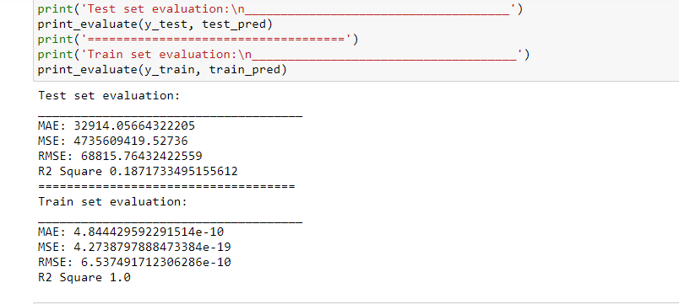

# 7. Stochastic Gradient Descent

Gradient Descent is a very generic optimization algorithm capable of finding optimal solutions to a wide range of problems. The general idea of Gradient Sescent is to tweak parameters iteratively in order to minimize a cost function. Gradient Descent measures the local gradient of the error function with regards to the parameters vector, and it goes in the direction of descending gradient. Once the gradient is zero, you have reached a minimum.

In [1159]:

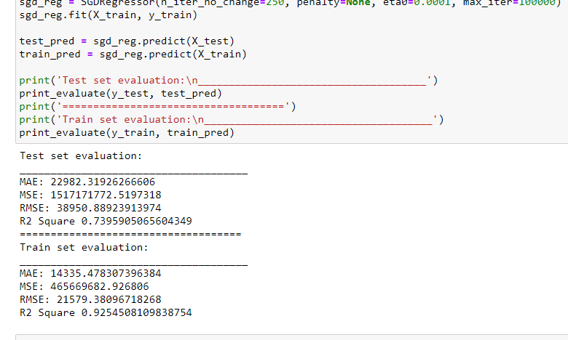

# 8. Random Forest Regressor[¶](http://localhost:8888/notebooks/PFA%20%20housing%20project.ipynb" \l "8.-Random-Forest-Regressor)

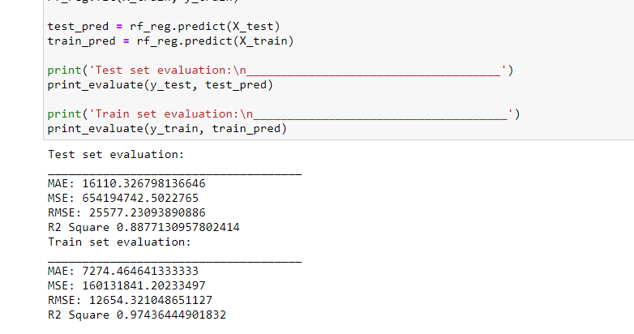

# 9. Support Vector Machine

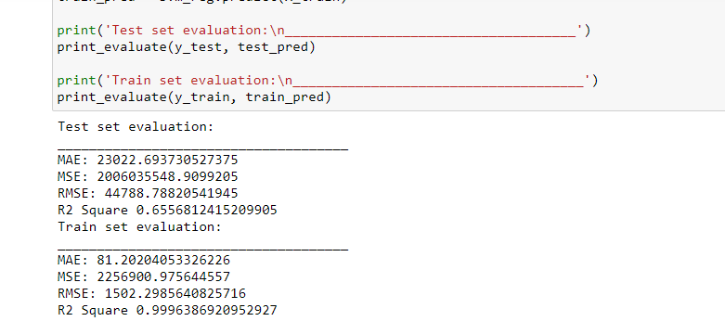

From bagging/boosting techniques🡪

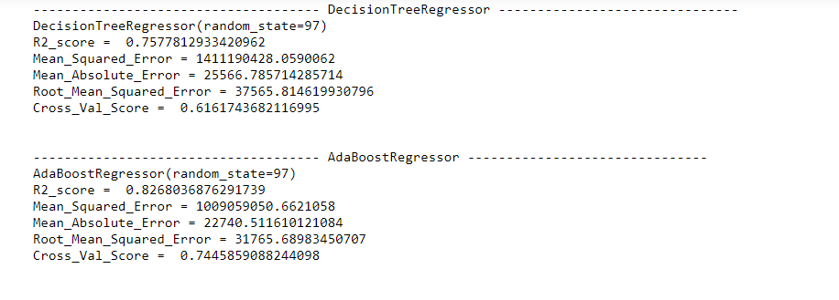

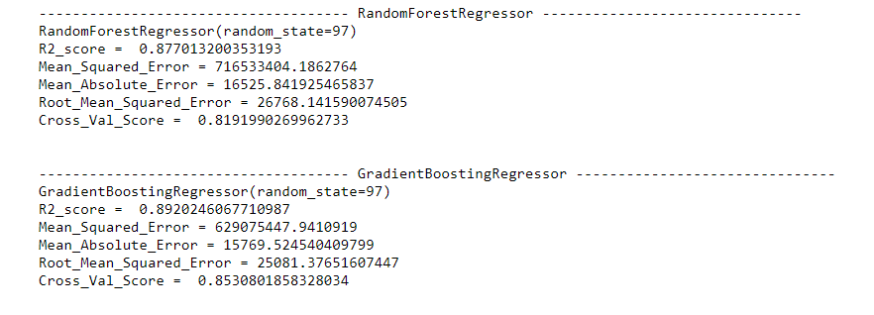

Finally we got gradient boosting technique with r2 score of 89.9.

* Key Metrics for success in solving problem under consideration

Randomised search cv was used over gradient boosting regressor which was in effective of the outliers in many columns.

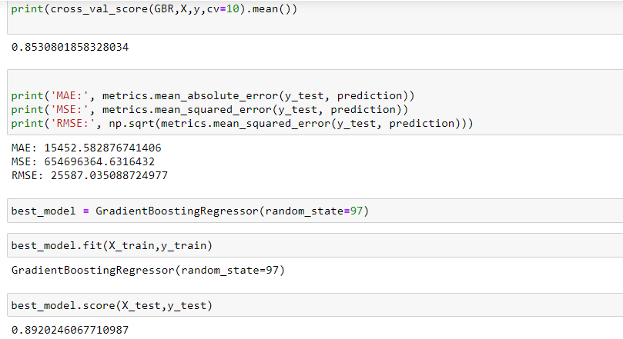

* Visualizations

As there were 80 columns so lot of graphs been used so summarising the graphs I used for categorical data/Numerical data,

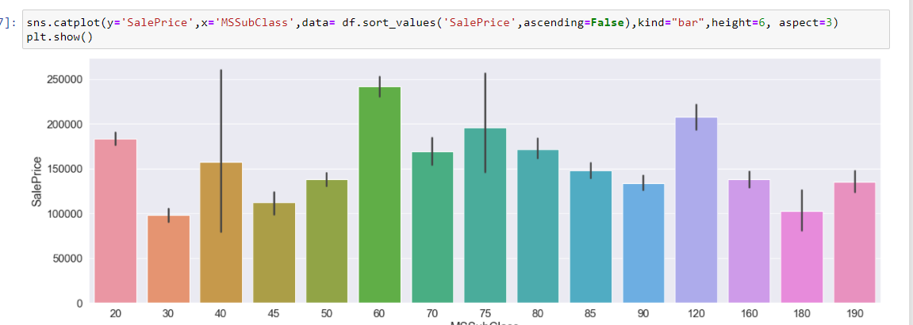

Graphs were made via matplotlib and seaborn, where sale price was checked with effect of inputs.

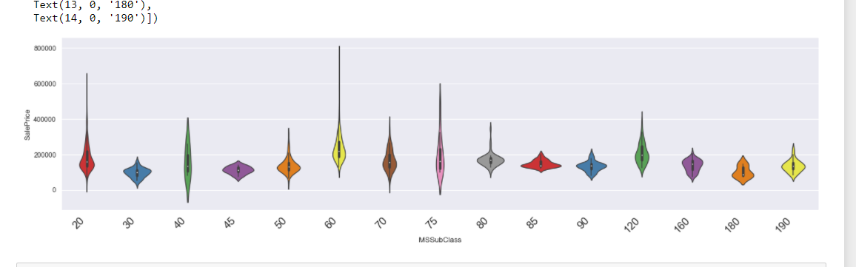

Again sale prices are checked with input features and effect was checked positively and negatively.

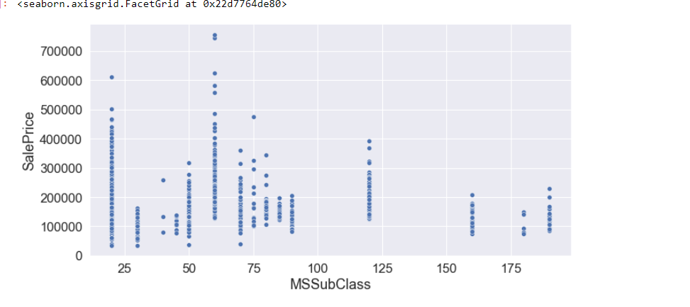

Count of maximum density was checked for each column taking sale prices into actions.

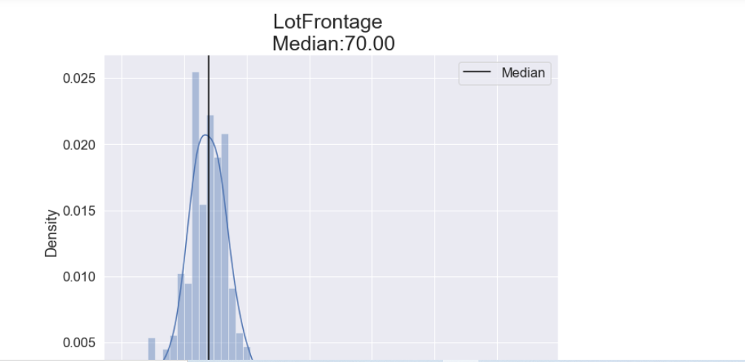

Median and skewness was checked for numerical data via these graphs.

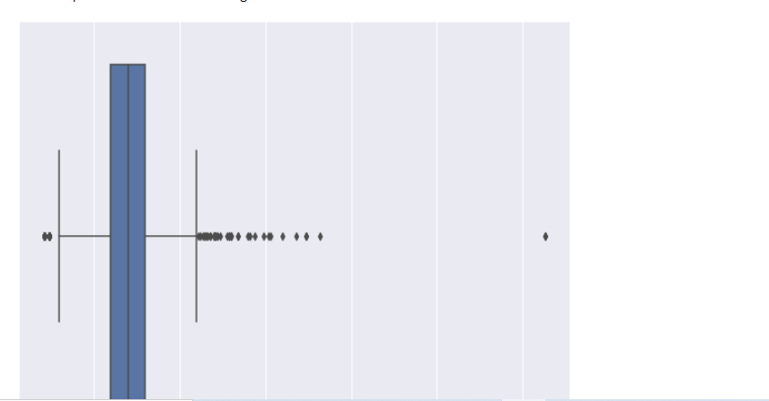

Outliers were checked for maximum via box plots .

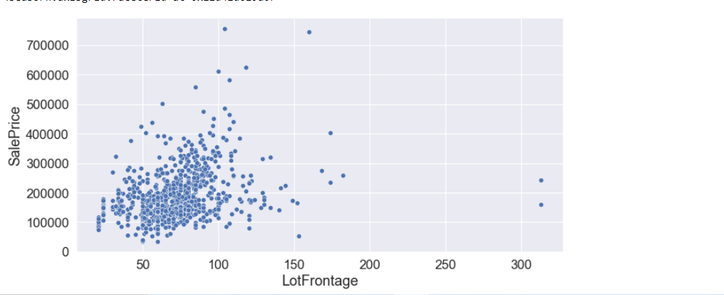

Now here from these graphs, I checked density where maximum houses lies in between for numerical features taking into.

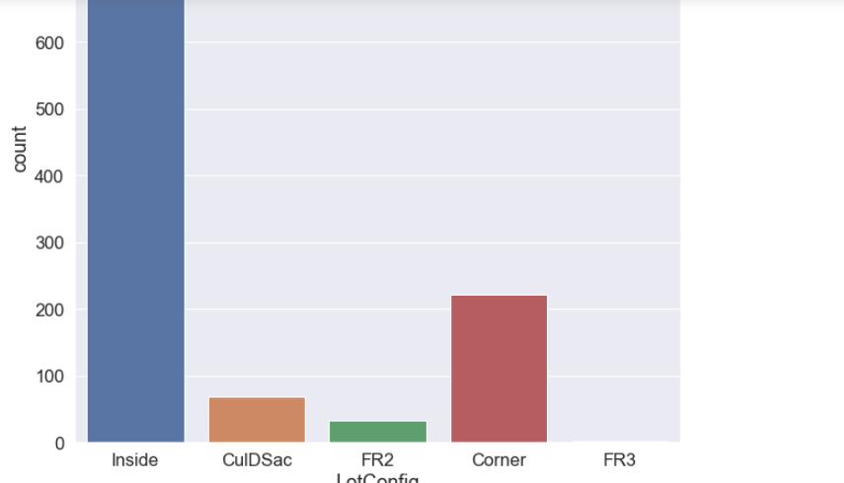

Via count plots, count was checked for categorical features.

Interpretation of the Results

Given all data into account, sale prices are effected by taking on number of utilities, for example having furnished garage and 3 fire exit places will eventually increase the house sale prices .

**CONCLUSION**

* Key Findings and Conclusions of the Study

From the whole problem statement, my key findings are as company can look to buy those houses with key variables as 1 kitchen , 4-5 bedrooms, basement bathroom, and the conditions variable of the houses which will cost them at median prices, company should not buy houses having numbers of bedrooms and bathroom because that just increase prices.

* Learning Outcomes of the Study in respect of Data Science

From the power of visualization, data cleaning and various algorithms used, company can look to buy those houses with key variables as 1 kitchen , 4-5 bedrooms, basement bathroom, and the conditions variable of the houses which will cost them at median prices, company should not buy houses having numbers of bedrooms and bathroom because that just increase prices.

And in this housing project, I calculated that GRADIENT BOOST REGRESSOR works awesome with r2 value of 86 and cross val score 89, linear regression is prone to outliers so won’t work in this project.

* Limitations of this work and Scope for Future Work

The limitations of the solution provided are that there are few houses that have basic features and excellent features as well but prices are either very low or very high with basic features , that can imbalance the cost of the company. The steps/technique to be used is to reduce the redundant features and increase the size of data will help to predict more.

# THANKYOU